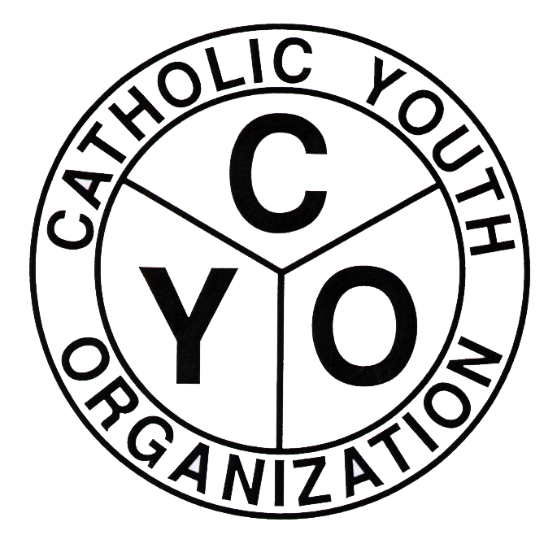
Catholic Youth Organization
7200 Douglaston Parkway
Douglaston, NY 11362
Tel.: 718.281.9548
Fax.: 718.281.9557
Website: www.cyodob.org

CYO COVID POLICY 2022-23

CYO athletes who develop COVID, as verified by testing, must isolate and refrain from all CYO activity for 5 days, beginning with the first full day following the experiencing of symptoms. If no symptoms, but a positive test, the 5 day period begins the first full day after the test was taken.

The athlete may resume CYO activity on the 6th day as long as no longer experiencing symptoms, including no fever without suppression medicines (aspirin, etc.).

Notification procedures-
The family must immediately notify coach, and the principal at the school the athlete attends.
The coach notifies the families of other team members and the PAR.
The PAR notifies the CYO Director, the Pastor, and the principal of the Diocesan Academy located in the parish (if there is one), whether the athlete attends the academy or not, as long as there are academy students on the team.
The CYO Director notifies the Office of the School Superintendent.

Exposed coaches and teammates do not have to isolate but do need to carefully monitor their health for symptoms developing following exposure and may want to but are not required to test.

